Legends of War Art Assets

Priority Chart

|  |  |  |  |  |
| --- | --- | --- | --- | --- |
| Wants | Low | Medium | High | Must Have |
| Grey | Green | Blue | Purple | Orange |

# **Level Art**

* Assassin Hero(Must)
  + A 3D model for the in game “assassin” hero, the assassin Raven will be a female character, with long black hair of moderate build. She will be dressed in dark leather wielding a dagger. The character will most resemble Katarina from League of Legends
  + 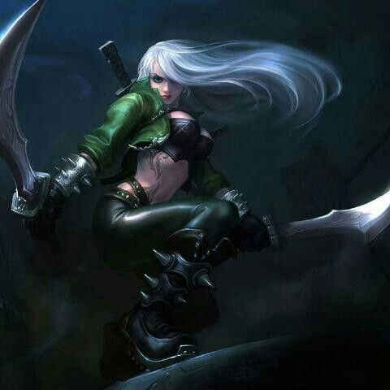
* Caster Hero(Medium)
  + A 3D model for the in game "Caster" hero. The Caster Serath will be a mid-sized male with robe covering most of his body and a face covering mask. He will be carrying a wand for his magic casting.
  + 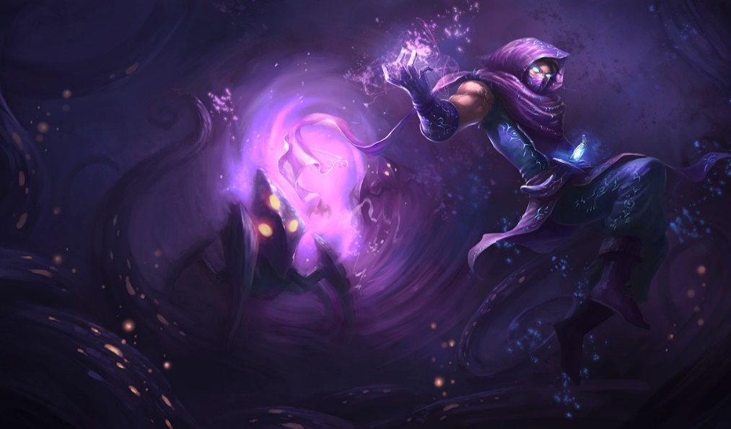
* Hunter Hero(Low)
  + A 3D model for the in game “Hunter” hero. The Hunter hero Cywen will be a slender female character, with green armor, a green hood, and light hair. She will carry daggers on her belt, and plant matter/wood armor. Her weapon is a bow.
  + 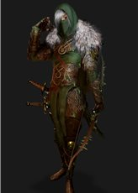
* Tank Hero(Must)
  + A 3D model for the in game "Tank" hero. The Tank hero Goliath will be a masculine male character, with short and dark hair. He will be carrying a big sized shield and some tough armor around him. His weapon is a mace.
  + 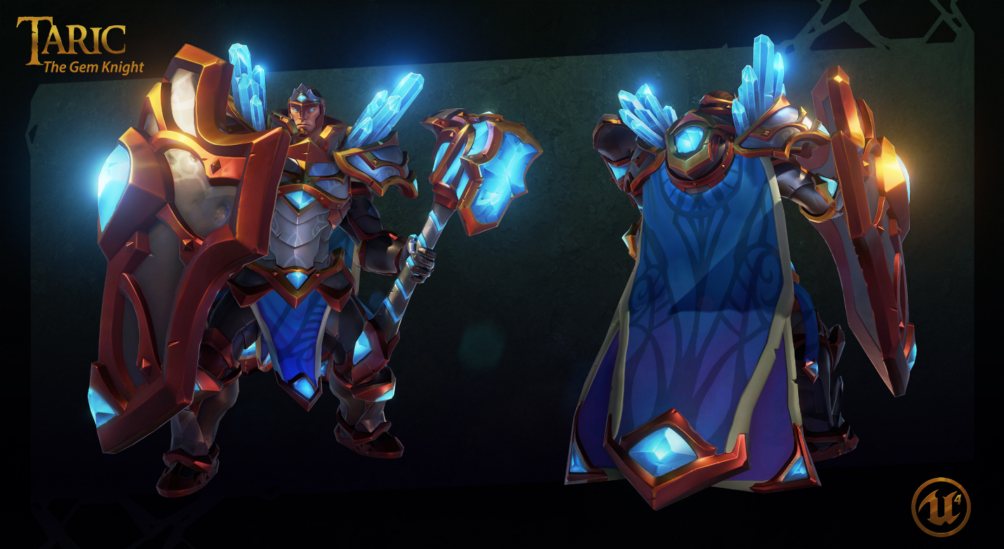
* Support Hero(Low)
  + A 3D model for the in game "Support" hero. The hero Princess wears light armor, and is of slam build carrying a staff. Her hair is long and blonde; her actions are cheerful.
  + 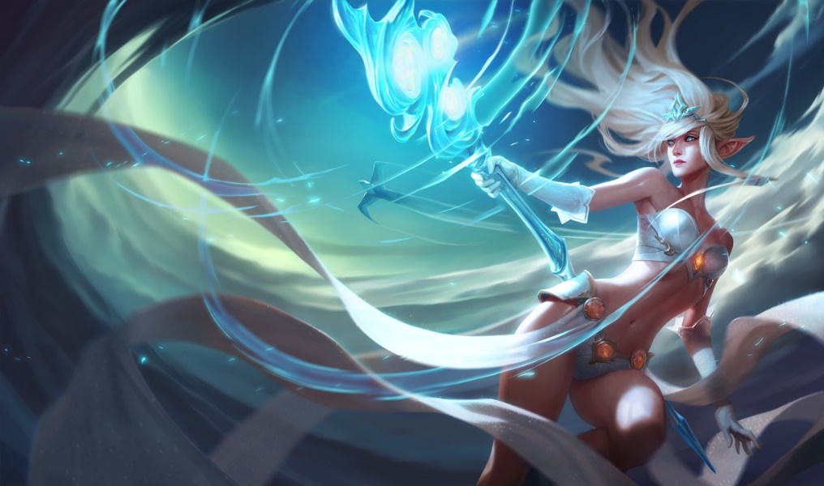
* Striker Minion(Must)
  + A 3D model for the in game melee “striker” minion. The minions will be smaller, and much shorter than the hero models, standing at only half as tall. The striker will wield a sword and shield combo, and be dressed in leather. There need to be two variations for the minion, one with a red coloration, and one with a blue coloration. For the opposing teams.
  + 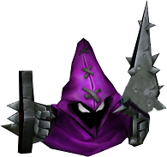
* Defense Minion(Medium)
  + A 3D model for the in game melee “striker” minion. The minions will be smaller, and much shorter than the hero models, standing at only half as tall. The Tank will wield a club or mace and shield, and be dressed in armor plates. There need to be two variations for the minion, one with a red coloration, and one with a blue coloration. For the opposing teams.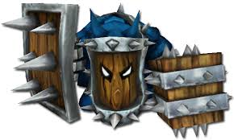
* Caster Minion(Medium)
  + A 3D model for the in game melee “striker” minion. The minions will be smaller, and much shorter than the hero models, standing at only half as tall. The caster minion will be using a book or talisman, and be dressed in flowing robes. There need to be two variations for the minion, one with a red coloration, and one with a blue coloration. For the opposing teams.
  + 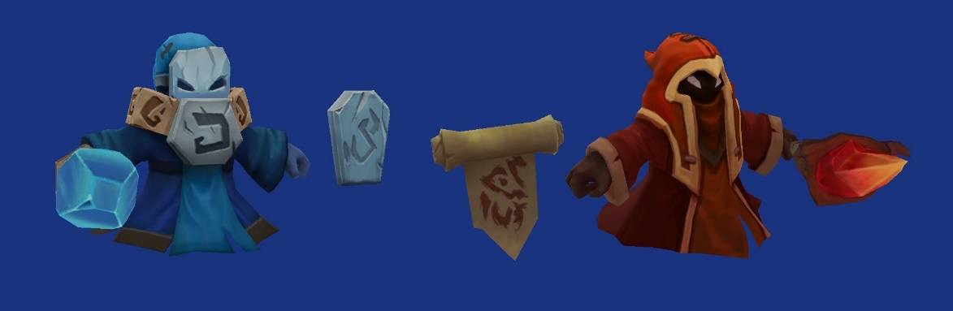
* Home Base(Must)
  + A 3D model for the red and blue bases. The bases will be circles that stand vertically on a stone platform. The outer edges of the circles will be surrounded by arcane symbols that will flash in their respective colors when units spawn from them. The inner part of the circles will have a blue or red event horizon representing a portal.
  + 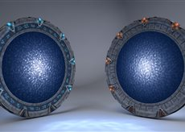
* Tower(Must)
  + The “tower” is a statue sentinel that protects the lanes leading to home base. It will be of grew marble like build with runic symbols on its base. The statue will stand tall in a slim armor, holding a massive sword in a vertical position.
  + 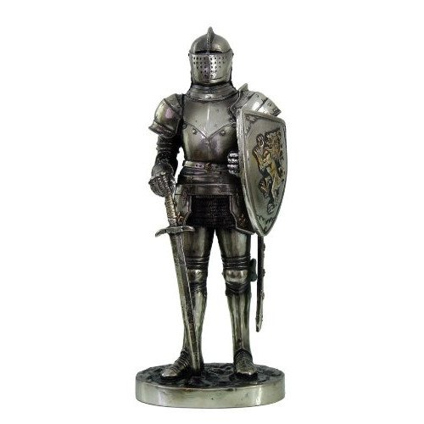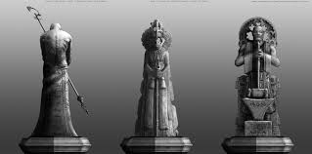
* Level Assets(wants)
  + The battel and game take place in a mountain/valley like ruin. With different unpassable objects placed about the battle field. Below is a list of assets that will be found in the world
    - Trees, the game taking place in the mountain, and will have trees that are of a longer trunk, with branches not showing till one half to three fourths of the way up the tree.
      * 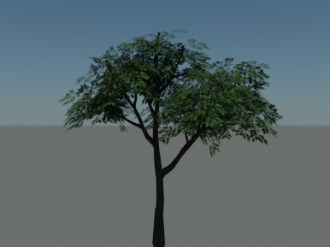
    - Pillars, they need to be runic, or temple like pillars, that can be placed at different angles and locations.
      * 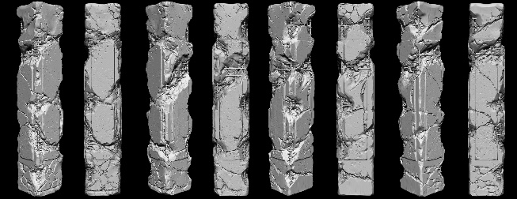
    - Rocks, being in the mountains means rocks will fall, or have fallen onto the ground, some of these larger boulders are placed randomly around the battle field.
    - 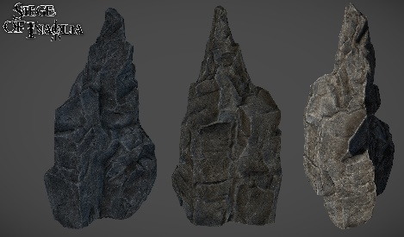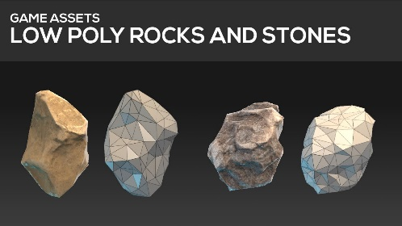

# **Special Effects**

* Character/Minion Particles
  + Assassin Hero
    - Attacking: When the Assassin uses a basic attack a short sound clip will play that sounds like daggers hitting armor.
    - Damage: When receiving damage, a red aura will pulsate around the screen.
    - Ability 1: Shank. When shank is used, a cross of red or blue slashes will appear over the targeted unit or hero.
      * 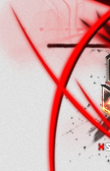
    - Ability 2: Assassinate. When assassinate is used a single horizontal red or blue slash will appear over the targeted unit or hero.
      * 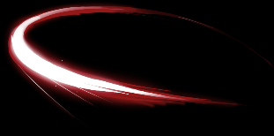
    - Ability 3: Poison Strike. When Poison Strike is used, a green semi-transparent icon will appear over the targeted unit or hero.
      * 
    - Ability 4: Sprint.
  + Caster Hero
    - Attacking: When the Caster uses a basic attack a short sound clip will play that sounds like an energy bolt being fired.
    - Damage: When receiving damage, a red aura will pulsate around the screen.
    - Ability 1: Engulf. When Engulf is used, an orange semi-transparent effect resembling an explosion will appear at the targeted unit or hero.

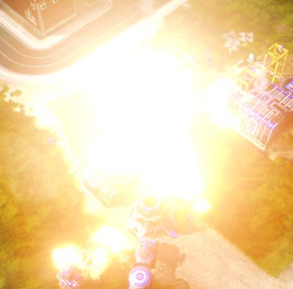

* + - Ability 2: The Zone. When The Zone is used, an orange circular area of effect appears on the targeted location, and persists for a few seconds.

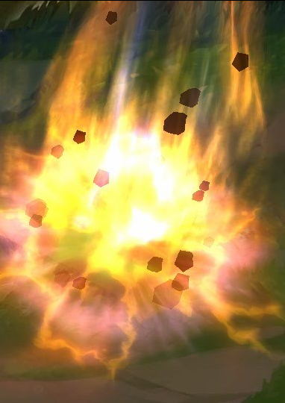

* + - Ability 3: Burn. When Burn is used the targeted unit or hero will have an orange particle effect emanating from his torso, and flowing upwards and outwards. This effect represents damage over time, so it will persist for some time.
    - Ability 4: Sprint.
  + Hunter Hero
    - Attacking: When the Hunter uses a basic attack a short sound clip will play that sounds like a bow being released.
    - Damage: When receiving damage, a red aura will pulsate around the screen.
    - Ability 1: Hunter’s Mark. A semi-transparent red arrow appears over the targeted unit or hero.
      * 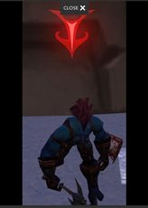
    - Ability 2: Rooting Shot. Roots appear at the feet of the targeted unit or hero.
      * 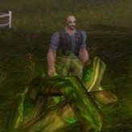
    - Ability 3: Charged Shot. A semi-transparent bullseye icon appears over the Hunter’s head.
      * 
    - Ability 4: Sprint
  + Tank Hero
    - Attacking: When the Tank uses a basic attack a short sound clip will play that sounds like a mace strike.
    - Damage: When receiving damage, a red aura will pulsate around the screen.
    - Ability 1: Brace. When brace is used, a blue semi-transparent shield icon will appear over the Tank.
    - Ability 2: Charge. When charge is used, the Tank will dash in the targeted direction. A semi-transparent, fixed sized, red or blue arrow will appear at the feet of the hero, and extend toward the target.
      * 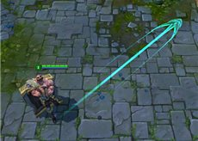
    - Ability 3: Cripple. When cripple is used, a semi-transparent broken bone icon appears over the head of the targeted hero or unit.
      * 
    - Ability 4: Sprint
  + Support Hero
    - Attacking: When the Support uses a basic attack a short sound clip will play that sounds like an energy bolt being fired.
    - Damage: When receiving damage, a red aura will pulsate around the screen.
    - Ability 1: Heal. When healing is cast, a green particle effect will emanate from the torso of the selected unit or hero, and flow upwards and outwards.
    - Ability 2: Buff. When Buff is used a halo icon appears over the selected unit or hero, and persists until the effect is ended.
    - Ability 3: Cyclone. When Cyclone is used, an area of effect appears on the map which appears like a swirling cyclone. This effect persists for a few seconds.
    - Ability 4: Sprint.
  + Ranged Minion
    - Attacking: When the ranged minion attacks a red or blue particle effect will appear around his weapon.

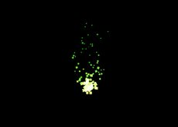

* Home Base Particles:
  + When the home base spawns a unit, a partially transparent effect will show being either red or blue depending on the base color.
    - 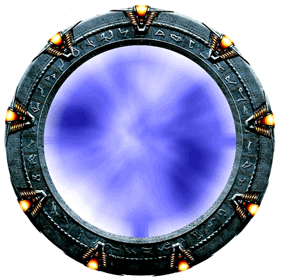
* Tower Particles:
  + When the towers take damage, a large particle effect will generate from the base of the tower. The particle effect will be red or blue depending on the color of the tower
    - 

# **Icons/Power Ups**

* Assassin Hero
  + Icon/Portrait
    - A small icon with the face or body of Raven
    - 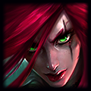
  + Ability 1
    - A special and high burst damage skill the icon needs to be some sort of slash, wave, or aoe dagger
  + Ability 2
    - A self-boost to damage which will be an “assassinate” ability the icon will look like a single special dagger, or attack from the shadows
  + Ability 3
    - The third ability is a damage over time poison, the icon needs to be a poisoned dagger, or snake/venom looking icon
  + Ability 4
    - The final ability is used by all heroes, and is a sprint/dash which will look like a running silhouette character.
  + 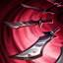 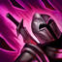 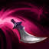
* Caster Hero
  + Icon/Portrait
    - A small icon that is the face of Serath.
    - 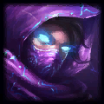
  + Ability 1
    - An aoe spell ability the icon needs to be an explosion of fire orange energy
  + Ability 2
    - A zone spell which summons a zone of fire, the icon needs to be a wall or ring of fire
  + Ability 3
    - A damage over time ability which will catch on fire, the icon should be a burning flame, or person on fire.
  + Ability 4
    - The final ability is used by all heroes, and is a sprint/dash which will look like a running silhouette character.
  + 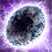 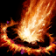 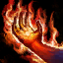
* Hunter Hero
  + Icon/Portrait
    - A small icon that is the face of Cywen
    - 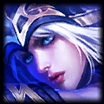
  + Ability 1
    - A hunters mark ability, the icon will be a red mark or target
  + Ability 2
    - Rooting shot, the ability will root a target to the ground, so the icon will be an arrow sticking gin the ground, or grasping vines
  + Ability 3
    - Charged shot is a heavy shot, the icon will be of a special arrow
  + Ability 4
    - The final ability is used by all heroes, and is a sprint/dash which will look like a running silhouette character.
  +  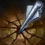 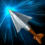
* Tank Hero
  + Icon/Portrait
    - Icon of Goliath
    - 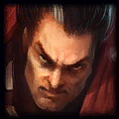
  + Ability 1
    - A brace ability that boost the tanks defensive ability, the icon is of a shield
  + Ability 2
    - A charge attack where the tank moves forward and does large damage, the icon is of a running man
  + Ability 3
    - A crippling strike, that slows and does damage over time, the icon is a bloody weapon.
  + Ability 4
    - The final ability is used by all heroes, and is a sprint/dash which will look like a running silhouette character.
  +  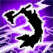 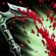
* Support Hero
  + Icon/Portrait
    - An icon of Princess
    - 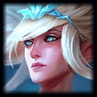
  + Ability 1
    - A special healing ability, the icon is a soothing aura
  + Ability 2
    - An aoe buff effect for units, an aura around a humanoid form
  + Ability 3
    - An aoe deterrent with slight damage, a spinning cyclone
  + Ability 4
    - The final ability is used by all heroes, and is a sprint/dash which will look like a running silhouette character.
  + 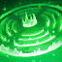 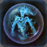 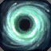
* Attack Minion
  + Base
    - A simple icon which shows the striker minion attacking
    - 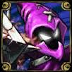
  + Tier
    - There will be a small emblem or roman numeral on the bottom right of the icon to symbolize which tier the minion is.
* Defense Minion
  + Base
    - A simple Icon which shows the tank minion bracing for an attack
    - 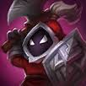
  + Tier
    - There will be a small emblem or roman numeral on the bottom right of the icon to symbolize which tier the minion is.
* Ranged Minion
  + Base
    - A simple icon which shows the caster minion preparing a spell
    - 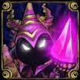
  + Tier
    - There will be a small emblem or roman numeral on the bottom right of the icon to symbolize which tier the minion is.

# **HUD**

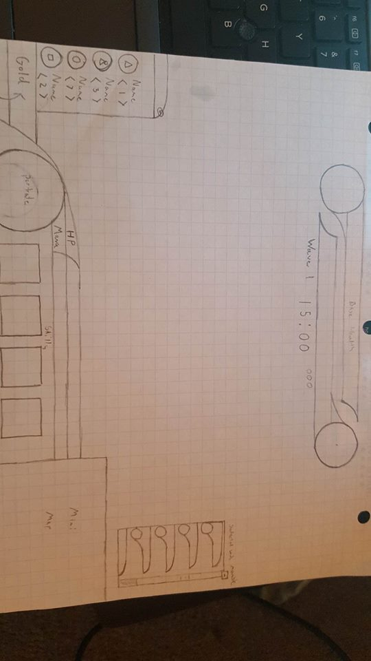

* Base Health Bars
  + At the top of the HUD are two healthbars, colored red and blue, they hold and show the health of the two bases
  + Below those are the EoG timer, and wave timers.
* Selected Units Module
  + On the far right is a movable hud items that will give information about the current units the player has selected
* Shop Module
  + On the far left is a small shop hud that will allow the player to change the amount of units spawning in next wave, either canceling purchase, or buying more of a unit already purchased
* Gold/Shop Button
  + Below that is the actual gold and shop icons, which will allow the player to go into the in game shop to purchase new units, and more
* Hero Information Overlay
  + In the center is the players characters information, such as an icon, health, and skills
* Mini Map Overlay
  + On the far right is the minimap
* Shop
  + There will be an overlay that opens when the shop is opened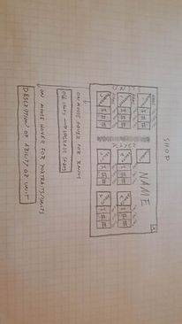

# **Menu’s**

* Main Menu
  + Button Design
    - The main menu will have rectangular buttons that will have a beveled ruinic design
  + Back Ground
    - The background will be of the game itself, with the valleys, and possibly characters, minions, or bases in the background
  + Legends of War Logo
    - The Legends of War Icon will take influence from the League of Legends Icon
* Pause Menu
  + Button Design
    - The buttons for the pause menu will follow the same pattern as the main menu, but will overlay just on a darkened in game screen.
  + Legends of War Logo
    - The same logo from the main menu will be present here
* Options Menu
  + Menu backdrop
    - The options menu will be over a dark backdrop and will give all the options to change volume, or other in game or important options
* Credits
  + The credits menu will have a scrolling credits constantly playing, there will be an exit button on the top of the page.